Create a simple cloud software application for Car Booking Reservation System using any Cloud Service Provider to demonstrate SaaS.

Aim :
To create and deploy a cloud-based Car Booking Reservation System using Zoho Creator in order to demonstrate the Software as a Service (SaaS) cloud computing model.

Procedure :
- Open a web browser and log in to Zoho Creator using a Zoho account.
- Click on Create New Application and select Create from Scratch.
- Choose Form-based Application and name it Car Booking Reservation System.
- Create a form named Car Booking Form.
- Add the following fields in the form:
  - Customer Name
  - Phone Number
  - Email ID
  - Car Type (Sedan, SUV, Hatchback)
  - Pickup Date
  - Pickup Time
  - Pickup Location
  - Drop Location
  - Booking Status (default value: Pending)
- Save the form. Zoho Creator automatically stores all data in its cloud database.
- Create a Tabular Report to view booking details.
- Configure basic workflow to display a confirmation message after form submission.
- Set user access permissions and publish the application.
- Access the application through the generated web URL.

Output :
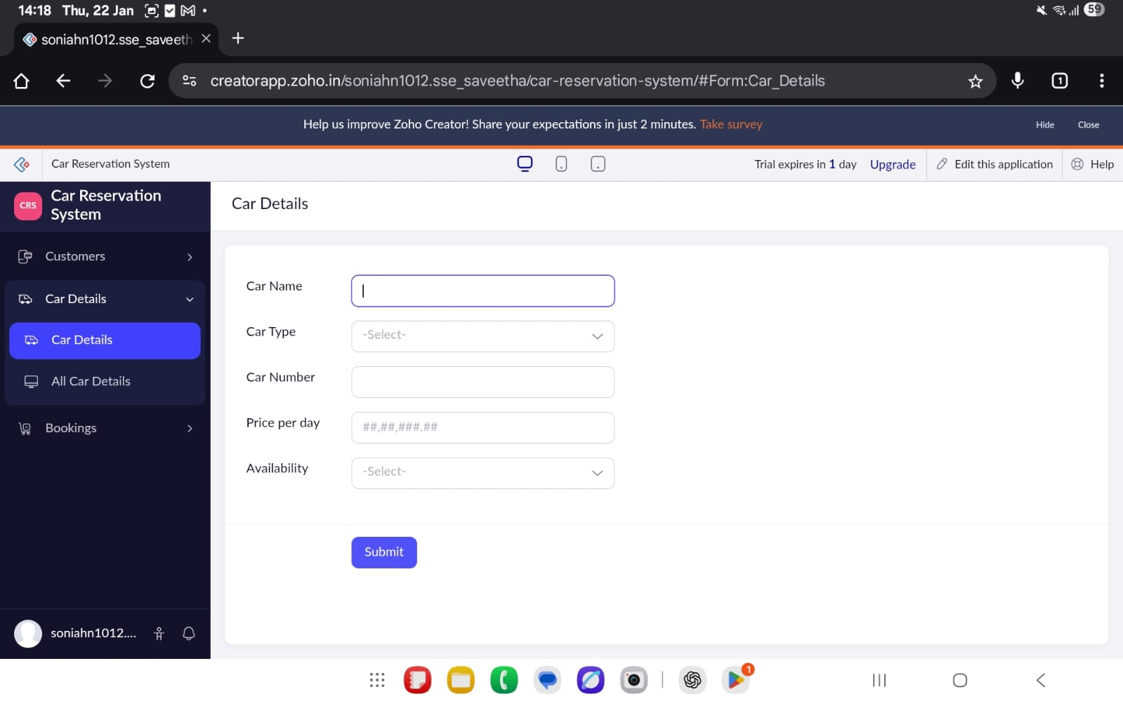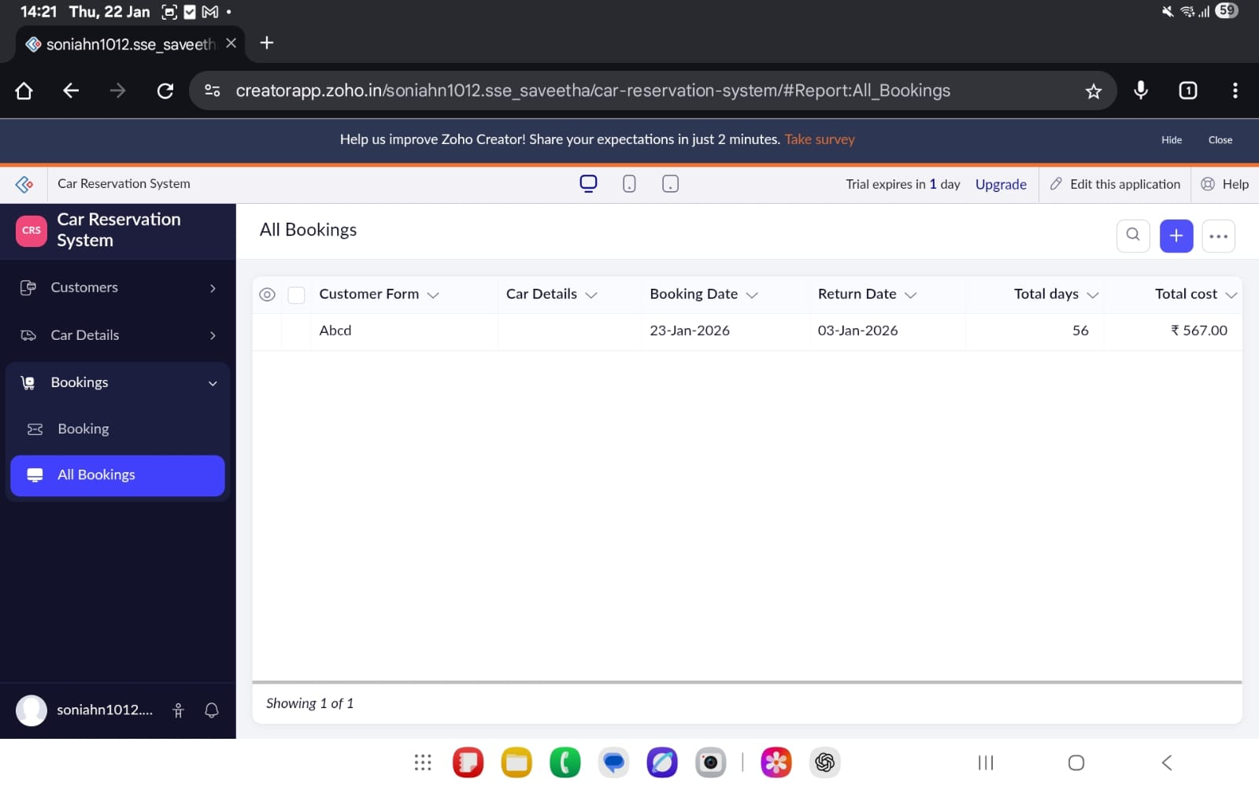
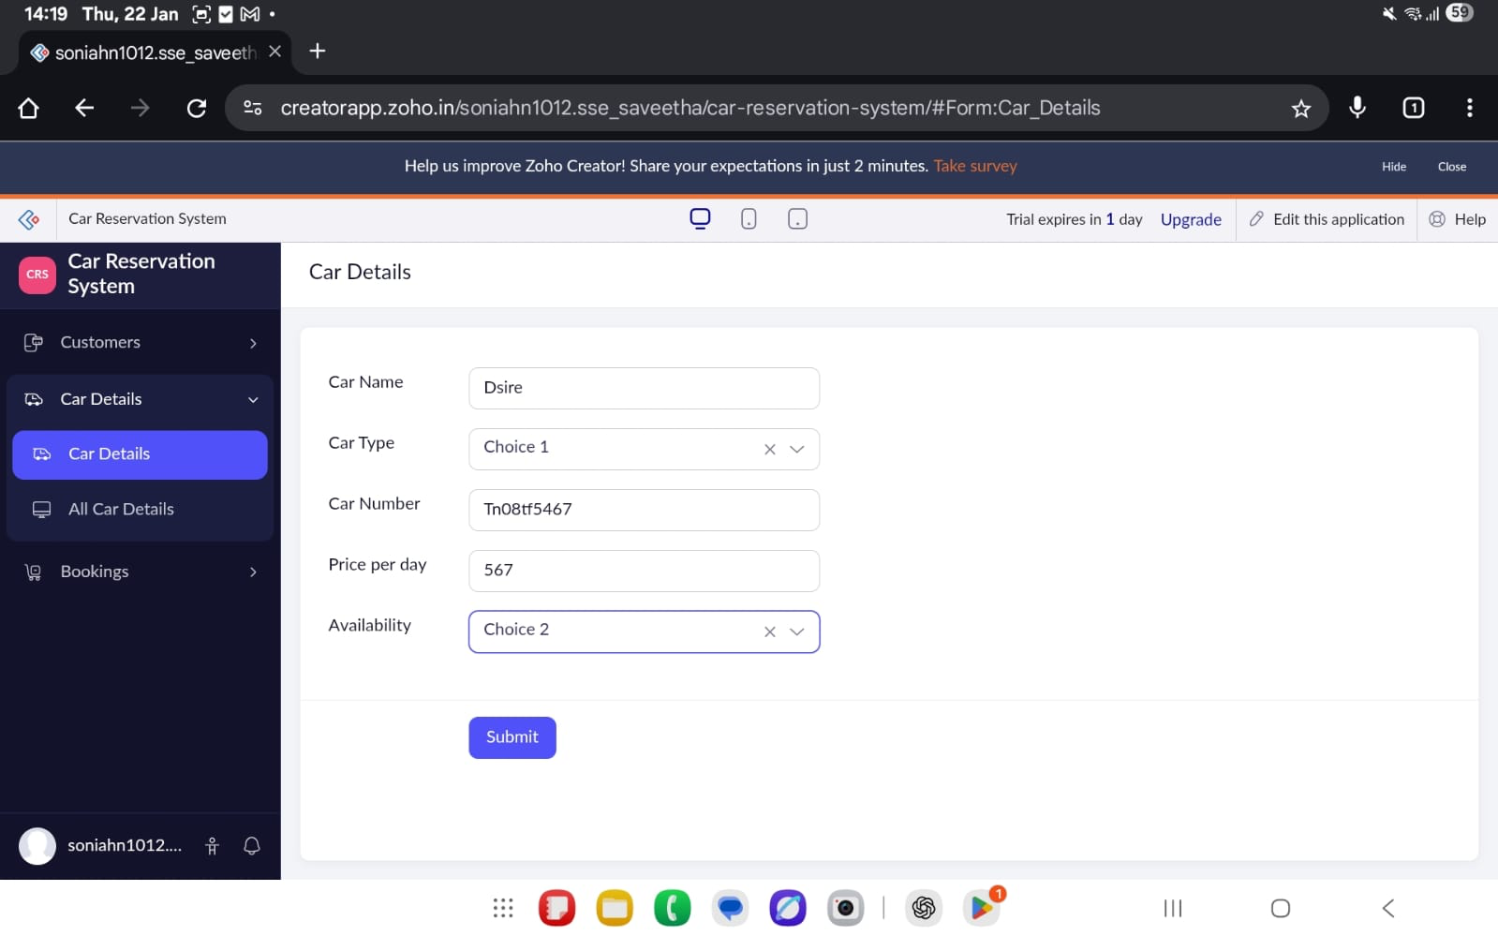
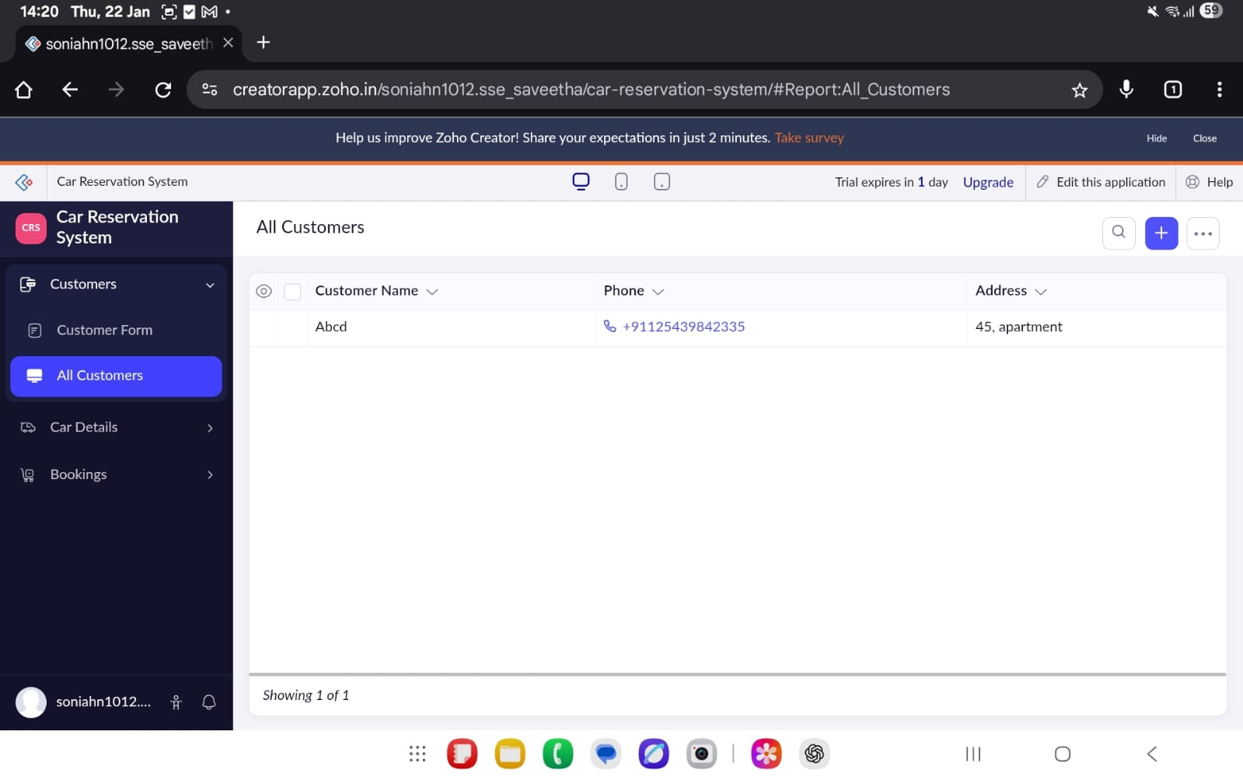

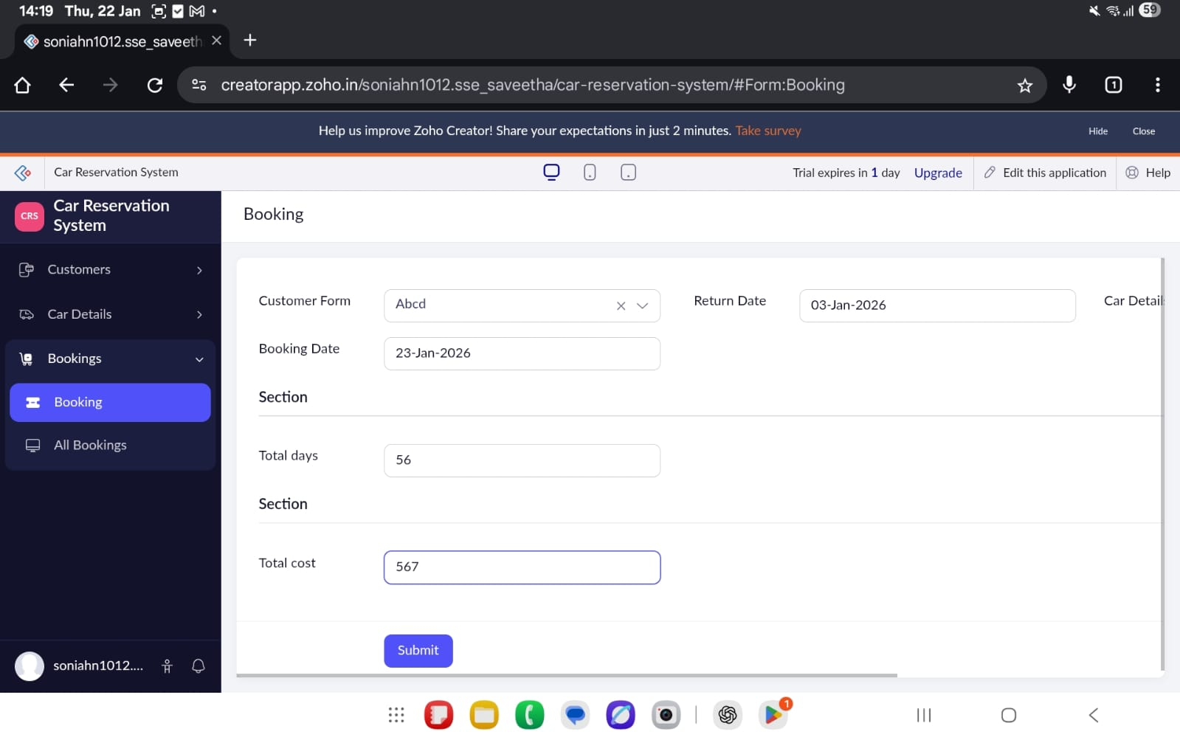
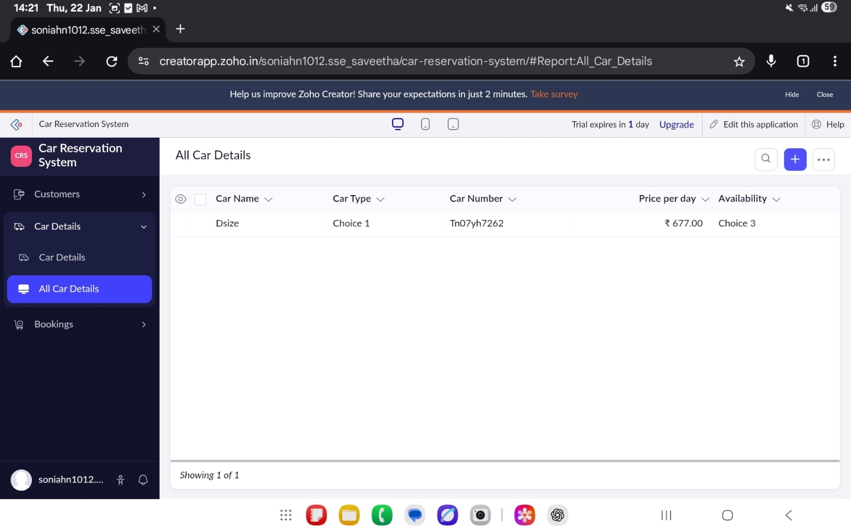
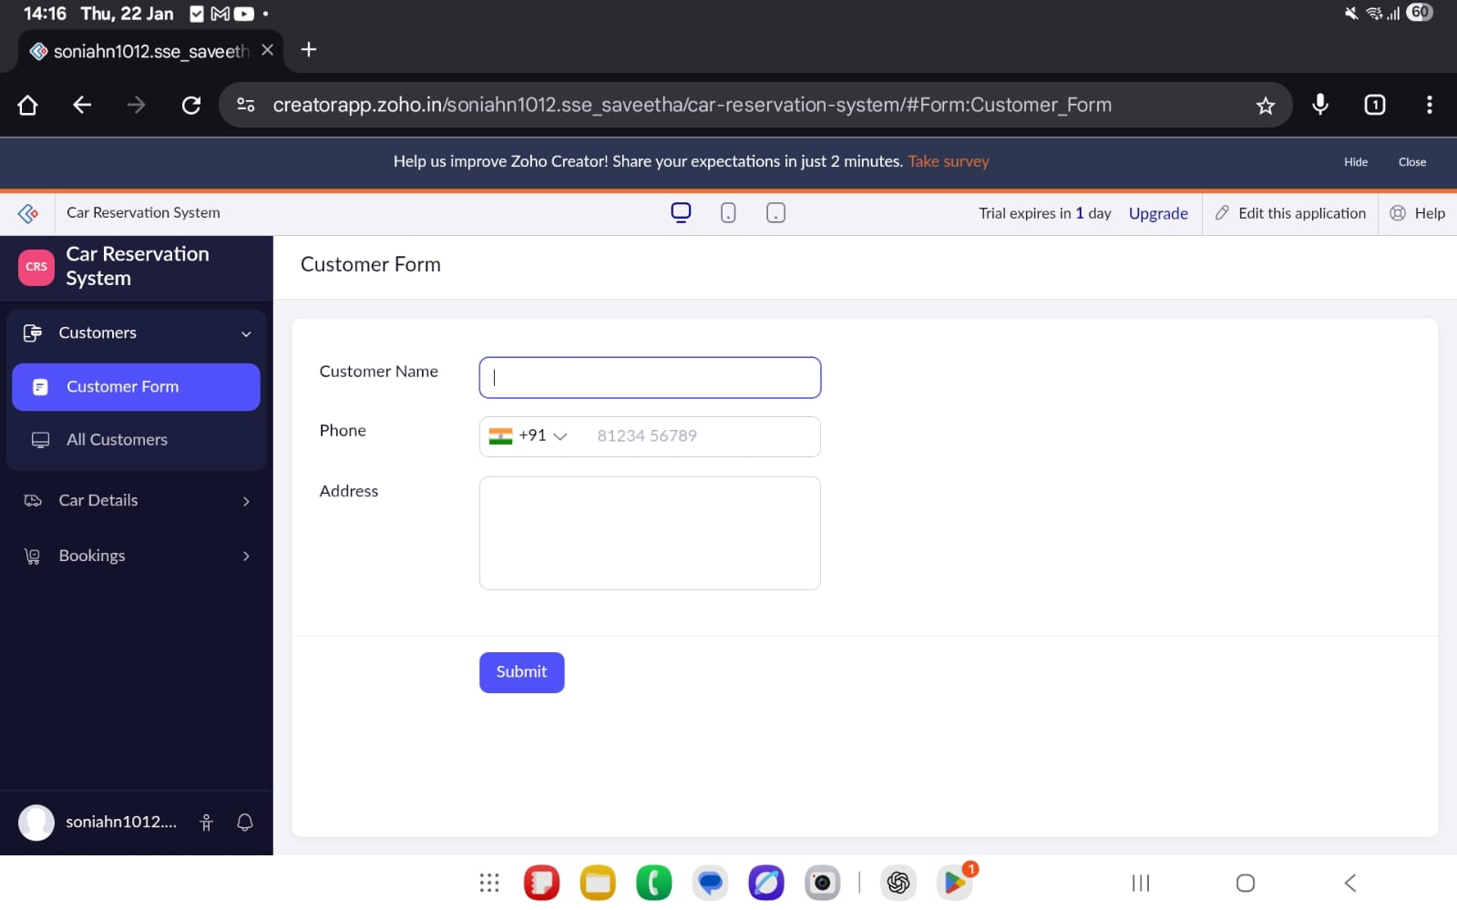
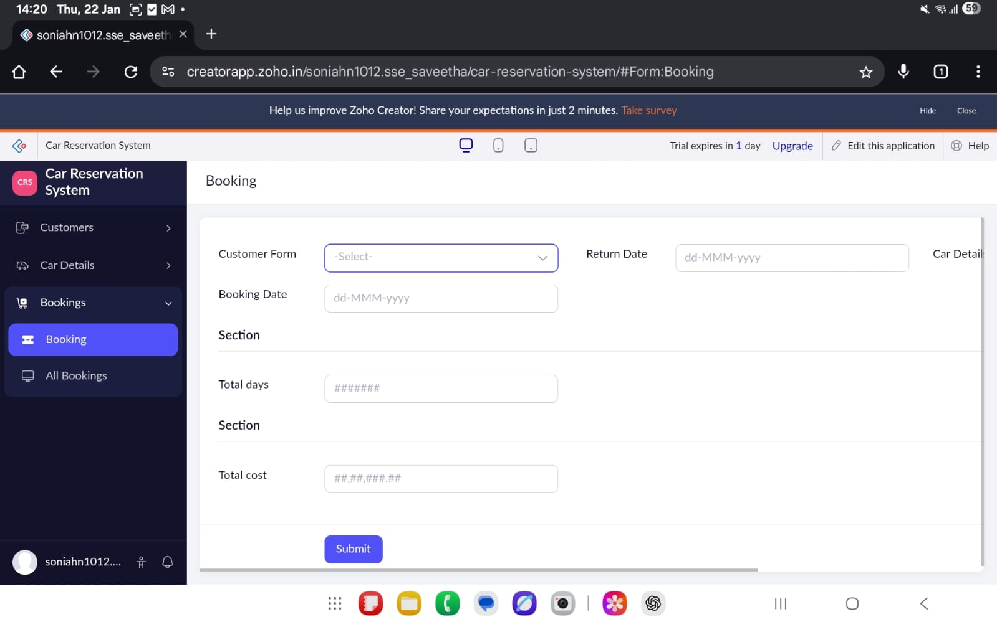

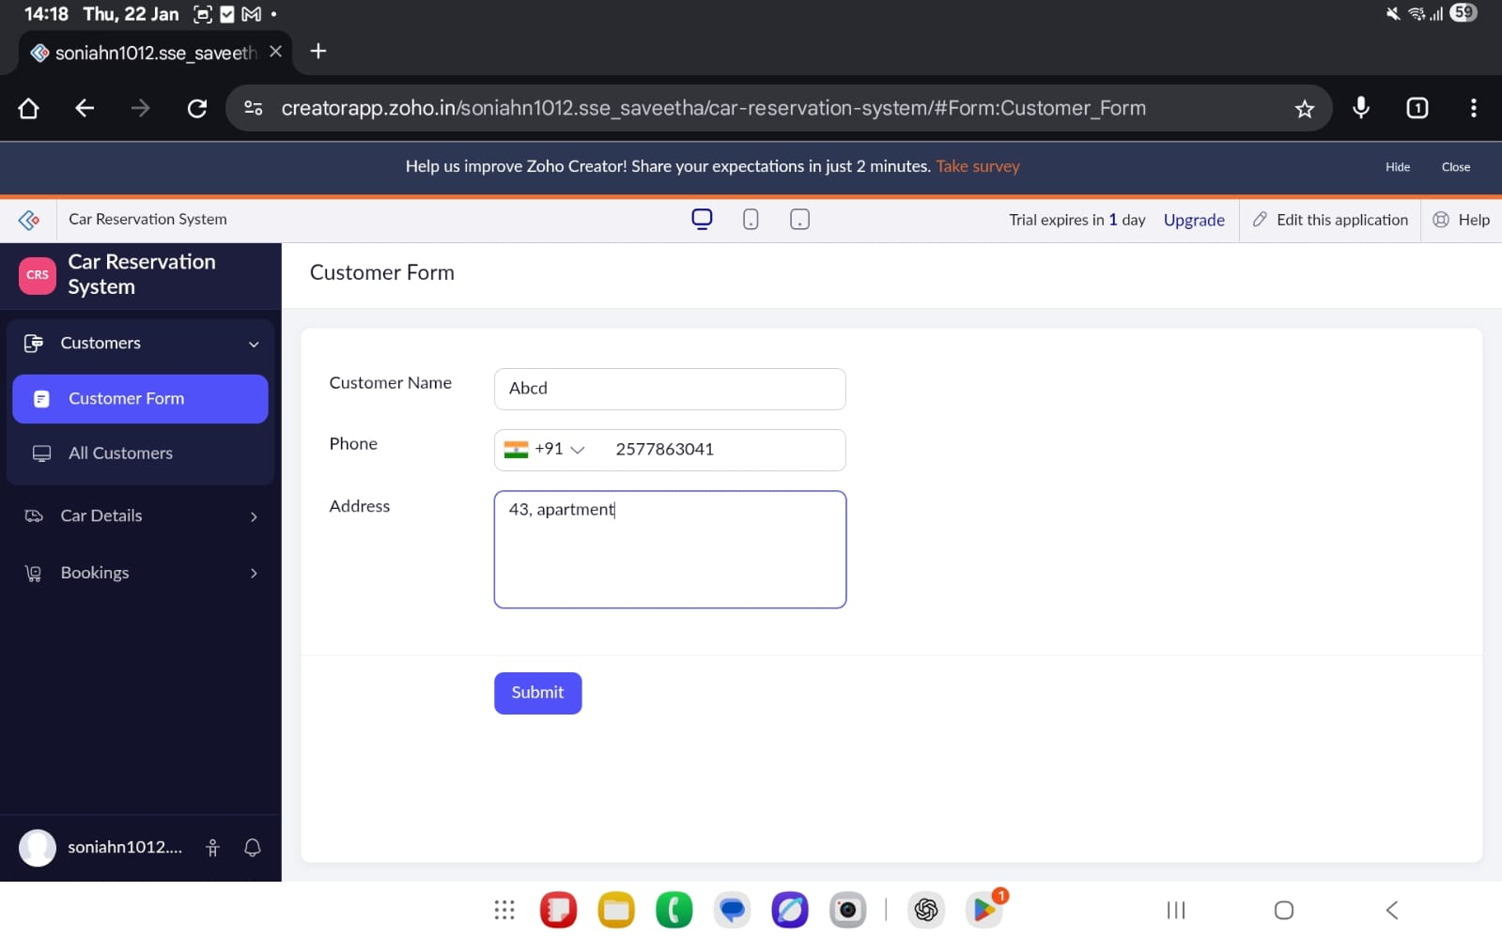

Result :
Thus, a Cloud-based Car Booking Reservation System was successfully created and deployed using Zoho Creator.The experiment clearly demonstrates the Software as a Service (SaaS) model, where the application is hosted, managed, and accessed entirely through the cloud.

